**Symbiosis School, Nashik.**

**Std: X Term I (2020-21)**

**Subject : English Language & Literature - Worksheet – 30**

**Lesson 7: Glimpses Of India**

**1. A Baker From Goa By Lucio Rodrigues**

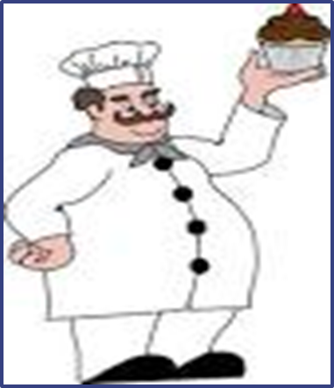

**About the Author**

**Lucio Rodrigues** (1916-73) was a great Konkani essayist. He wrote several articles in English and Konkani to various periodicals and magazines. He served as the visiting professor of Folklore at many universities and also as a professor of English in Mumbai and **Goa.** His essays were posthumously published under the title of ‘Of Soil and Soul’ and Konkani Folk Tales’. Subtle humour and informal narration are the essential features of his writings.

This is a pen-portrait of a traditional Goan village baker who still has an important place in his society

**Glimpses of India A Baker from Goa Introduction**

‘A Baker from Goa’ revolves around the relevance of a baker in the Goan culture which dates back to the time when Portuguese ruled over the city of Goa. The Portuguese may have left but the bread-makers continue to have an inevitable stature. In this story, the author recalls his childhood days and their excitement on seeing the baker. They were enthusiastic to the point that they would run to him as soon as they woke up without even brushing their teeth.

**Glimpses of India A Baker from Goa Summary**

The lesson begins with how narrator’s elders often recall the time when Goa was under the rule of the Portuguese. They talk how the importance of bakers is still maintained in their villages even after the Portuguese have left. They are known as ‘Paders’ in Goa. The mixers, moulders and their time-tested furnaces continue to serve the people of Goa with their famous bread loaves. It is possible that the original ones may not exist, but their profession is being continued by their sons. The thud of their bamboo stick can still be heard in some parts of the village. The same jingling thud would wake the narrator and his friends during their childhood days who would go running to him without brushing or washing their mouth properly.  It was the maid-servant of the house who collected the loaves while children sorted out the bread bangles for themselves. Bakery products have importance in the culture and traditions of Goa. Bol or sweet bread is a part of marriage gifts, cakes and Bolinhas or coconut cookies are eaten at every festival and the lady of the house prepares sandwiches at her daughter’s engagement. Earlier bakers wore a unique frock of knee-length known as ‘kabai’ but during the narrator’s childhood days, they wore a shirt and trousers of length slightly shorter than the usual ones. They generally collected their bills at the end of every month. Bakery has continued to be a profitable profession, managing to keep their families joyous and prosperous.

**Word Meanings**

Reminiscing nostalgically- thinking fondly of the past  
Loaves- (plural form of loaf) bread that is shaped and baked in a single piece and can be sliced for eating  
Vanished- disappear suddenly and completely  
Moulders- a person who moulds dough into a shape  
Furnaces- an enclosed structure in which materials can be heated to very high temperatures

Extinguished- cause a fire to cease to burn                                    
Heralding- announcing  
Pader- word for baker in Portuguese language

staff - stick  
Rebuke- an expression of disapproval; a scolding  
Fragrance- a pleasant, sweet smell  
Parapet- railing, a low protective wall  
bangles- here, refers to the bread in the shape of a bangle called ‘Kankon’

Feast- a large meal, typically a celebratory one  
bolinhas - another name for coconut cookies

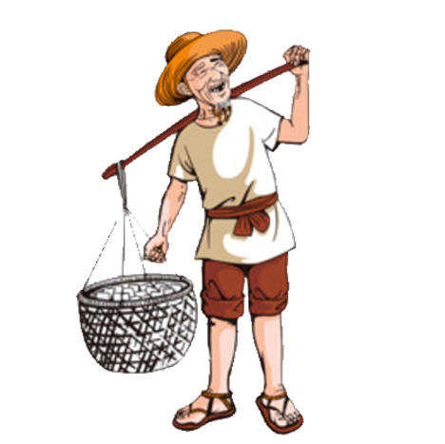

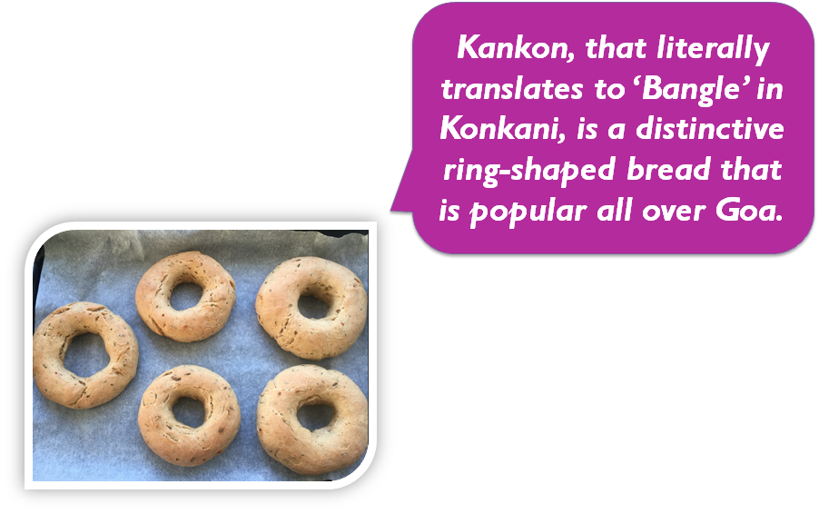

**Concept Based Questions**

**Question 1.**

What did the baker do first once he reached a house?

**Question 2.**

How did the baker make his entry?

**Question 3.**

How do we get to know that the makers of bread still exist?

**Question 4.**

What is the importance of breads for the Goans?  
or  
Why was the Baker’s furnace essential in a traditional Goan village?

**Question 5.**

Describe the dress of the bakers.